  

Head office: Warangal

Regional Office: Nalgonda

Branch: Lenkalapally

Date: 16/10/2023

TO WHOMSOEVER IT MAY CONCERN

This is to that Mr. Aithagoni Anjaiah, is having Savings Bank Account in our branch bearing A/C No 1628504000 with us and the credit balance as on Dt: 16/10/2023 is Rs. 41,13000 in words Forty One Lakh Thirteen Thousand Rupees only is equivalent to USD 49560 approximately @ Rs 82.99/- per US Dollar.

This Certificate is issued at the Specific request of the account holder for his son Mr. Aithagoni Shiva’s higher education admission purpose at USA.

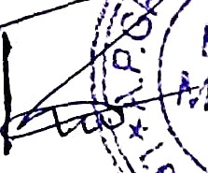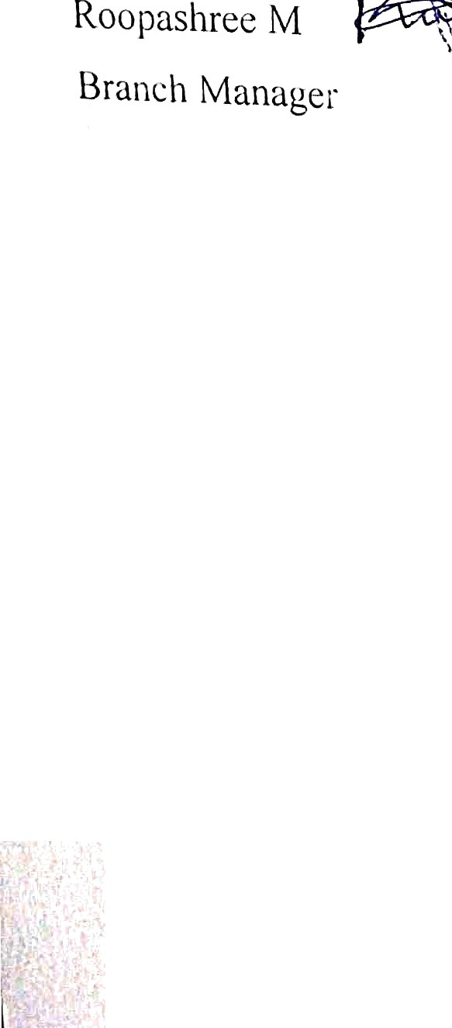

Signature of bank official